# Welcome to the Practice of Freedom

*What if we could listen*

*like the great salmon*

*who goes about its ordinary life*

*when suddenly something shifts.*

*It does not come as a thunderous*

*revelation, but a quiet knowing*

*you have been preparing all*

*your life to trust.*

*The path lived until now no longer*

*satisfies but the path ahead*

*seems thousands of miles*

*long, and your womb is heavy.*

*-Christine Valters Paintner*

*from her poem “*[*Following an Ancient Call*](https://abbeyofthearts.com/blog/2013/08/19/following-an-ancient-call-a-love-note-from-your-online-abbess/)*”*

Who of us doesn’t understand that “heavy womb”? Who of us hasn’t felt a deep hunger begin to grow in our bellies? Who of us hasn’t felt a particular new desire rise up, sure and clear? And who of us hasn’t—at some point—turned our backs on that desire, that call?

Not that we wanted to. It’s just that we were stuck. Imprisoned, so to speak, by circumstances, responsibilities, constraints or assumptions which made that desire seem out of reach. We felt trapped, forced to say “No” when our heart wanted to say “Yes”.

More often than we notice, this is the dilemma when it comes to freedom. It’s not so much about running away from something as it is about wanting to run *toward* something but not being able to! In other words, there is a big difference between “freedom from” and “freedom to.”

Our Unitarian Universalist faith gets this. At its best, it never simply asks us, “What do you need to get away from?” No, it pushes us to ask the deeper question of “What is it that you want to run toward?” Mature freedom is never about the absence of all constraints; it’s about being able to commit yourself to the things that have your heart. Or to put it another way, true freedom is about constraints *of our own choosing.*

So what is it for you, friends? Where in your life are you feeling forced to say “No” when your heart really wants to say “Yes”? What is it that you want to use your freedom for? It’s not the bars of a prison that make us want to escape; it’s suddenly noticing what’s on the other side of those bars that makes us want to get out.

So this month, don’t take your eyes off of it. Keep that longing clearly in view. And if you do, you’ll be surprised how easy it is to bend open those bars… and simply walk out.

# Our Spiritual Exercises

It’s one thing to analyze a theme; it’s quite another to experience it. By pulling us out of the space of *thinking* and into the space of *doing*, these exercises invite us to figure out not just what we have to say about life, but also what life has to say *to us*!

Pick the exercise that speaks to you the most. **Come to your group ready to share why you picked the exercise you did, where it surprised you and what gift it gave you.**

## Option A

## Getting Reacquainted with Your Core Values

In our welcome to this packet, we lifted up the truth that freedom is not about the absence of all constraints, but instead about being able to stay tethered to the things that have our heart. Being clear about our core values is a big part of this. The more distant or blurry our core values become, the easier it is to be lured by and trapped in priorities and projects of someone else’s making. This is why the work of repeatedly reacquainting ourselves with our values matters so much. Keeping them close and clear keeps us free.

With this in mind, we’ve created a values clarification guide for you to work with this month. It is flexibly designed, so you can engage it *as simply or elaborately as you like*. Here’s the link to it:

<https://docs.google.com/document/d/1UIYQcsyRo_NY619XeG9bMnbtu_HvGWVnwFYQcV7t6Wo/edit?usp=sharing>

Come to your group ready to share what most surprised you about the exercise as well as the most significant insight you gained from it.

## Option B

## The Escape of a Carefree Moment

There are some things we can never escape: a diagnosis, a loss of a loved one, loss of a job, regret, worry, the numbing repetition of daily life, the joy-filled but nonstop responsibility of parenting. Some of these burdens are rare; some are routine. But regardless of their weight or intensity, we find ourselves longing for a reprieve. A spiritual timeout. A temporary moment of escape that lets us feel carefree just long enough to be refilled or get our resilience back.

That’s what this spiritual exercise is all about: Carving out some space to feel carefree.

To be specific, here’s what we’re inviting you to do:

1. Find a moment of quiet and watch this video: <https://www.youtube.com/watch?v=pMWU8dEKwXw>. It may not exactly represent what’s weighing you down, but use the emotions that arise from it to spark your imagination and motivation.
2. Spend some time identifying the burden, weight or responsibility from which you need to break free from, if only for a short time.
3. Then come up with and do something to give yourself that escape. Do something that leaves you feeling carefree. Take your time figuring this out. In fact, pushing yourself to identify exactly what allows you to feel carefree is the whole point!
4. Come back to your group prepared to share the gift that this moment of freedom gave you.

## Option C

## Help Them Escape

Sometimes it’s not us that need a moment of escape, but someone we care about. Stepping away, renewing oneself, and taking a break are not gifts that some people are good at giving themselves. Sometimes they need the help of someone who loves them. So maybe life is calling you to help them escape.

If you agree, then here is your task:

1. Find a moment of quiet and watch this video: <https://www.youtube.com/watch?v=pMWU8dEKwXw>.
2. Spend some time identifying someone in your circle of concern that is carrying a burden, weight or responsibility from which they need a brief time of escape.
3. Then do something to give them that gift, to leave them feeling carefree. You can be direct about it or sneaky. Sometimes gifts like these require surprise or anonymity. On the other hand, it might just require you dragging them into it. Either way, your assignment is to orchestrate it.
4. Come back to your group prepared to share the gift that this moment of freedom gave them… and you.

## Option D

## Your Story of Escape by Quitting

Quitting is arguably the most under-celebrated means of finding freedom. Indeed, if you add up all the big and small ways we do it, quitting may be the most used form of escape. And one of the most courageous. Whether it’s as life-altering as walking away from careers and friendships or as seemingly minor as giving up a hobby or a diet, quitting is never just freeing, it is always - to some degree - *terrifyingly* freeing. We humans just weren’t built for the unknown. A love of the familiar is deep in our bones. And yet virtually every story about quitting ends with the storyteller testifying to it being, in one way or another, a life-giving choice.

So, what’s your courageous quitting story? We all need to hear it. We all need reminding now and then of what lies on the other side of our caged comfort.

Come to your group ready to share not only your story, but what it taught you and why it means so much.

## Option E

## Which Companion Piece Speaks to You?

Sometimes we come across a quote, song, article or movie and it perfectly captures what’s going on for us right

now or allows us to view our current circumstances in a new light.

With this in mind, spend some time this month going through the Companion Pieces section below to find the one piece that speaks most powerfully to you. (Or “shimmers” most strongly for you.)

Come to your group ready to share the piece you picked, why it called to you and what insight, memory, or message of comfort or challenge it offered you.

## 

## Option F

## Ask Them About Freedom

One of the best ways to explore our monthly themes is to have conversations about them with people who are

close to you. It’s also a great way to deepen our relationships! Below is a list of questions to help you on your

way.

Be sure to let your conversation partner know in advance that this won’t be a typical conversation.

*Remember to also answer the questions yourself as they are meant to support a conversation, not just a time of*

*quizzing them.*

Come to your group ready to share what surprised you about the conversation and what gift or

insight it gave you.

**Freedom Questions:**

* When did you feel most free as a child?
* What is a song that always gives you the feeling of freedom when you hear it? Tell me a story about when it came to your rescue.
* What story from your life best captures your current understanding of freedom?
* Whose freedom do you envy?
* Has quitting ever set you free?
* What do you know now about freedom that you didn’t know when you were younger?
* The philosopher Jean-Paul Sartre said, “Freedom is what we do with what is done to us.” What story comes to mind when you hear that?
* When were you freed by love?

# *Your Question*

*This list of questions is an aid for deep reflection. How you answer them is often less important than the journey they take you on.*

*So, read through the list of questions 2-3 times until one question sticks out for you and captures your attention, or as some faith traditions say, until one of the questions “*[*shimmers*](https://www.findingsolace.org/how-to-practice-lectio-divina/)*.”*

*Then reflect on that question using one or all of these questions:*

* *What is going on in my life right now that makes this question so pronounced for me?*
* *How might my inner voice be trying to* [*speak to me*](https://leftbrainbuddha.com/secular-lectio-divina/#:~:text=Lectio%20Divina%20is%20Latin%20for,to%20%E2%80%9Cspeak%E2%80%9D%20to%20you.) *through it?*
* *How might Life or my inner voice be trying to offer me a word of comfort or challenge through this question?*

1. When did you feel most free as a child?
2. Has quitting ever set you free?
3. Has freedom ever frightened you? What did that moment teach you?
4. Is aging trying to offer you a new form of freedom? What is keeping you from accepting that offer?
5. What has life taught you about being imprisoned without realizing it?
6. What story from your life best captures your understanding of freedom?
7. Whose freedom do you envy?
8. Has numbing become your cage?
9. Are you stuck in an old survival mechanism that isn’t needed anymore?
10. What form of “imprisonment” are you most vulnerable to? Fear? The need for safety? Woundedness? Shame? Self-doubt? Anger? Fear of rejection? The inability to say sorry? Regret? Gossip? Society’s standards of beauty? Your own standard of living?
11. Has seeking safety ever become your jail cell?
12. Have you ever been trapped in someone else’s story?
13. Would living more simply bring you more freedom?
14. When were you freed by love?
15. **What’s your question?** Your question may not be listed above. As always, if the above questions don't include what life is asking from you, spend the month listening to your days to find it.

# *Companion Pieces*

***Recommended Resources for Personal Exploration & Reflection***

*The following resources are not required reading. Nor are they intended to be analyzed in your group.*

*Instead they are here to companion you on your personal journey this month, get you thinking*

*and open you up to new ways of embodying the practice of freedom in your life.*

### 

### 

### Wise Words

You must learn one thing.

The world was made to be free in.

Give up all the other worlds

except the one to which you belong.

Sometimes it takes darkness and the sweet

confinement of your aloneness

to learn

anything or anyone

that does not bring you alive

is too small for you.

[David Whyte](https://onbeing.org/poetry/sweet-darkness/)

The bird you put inside a cage, you will have to find it another name, for it is no longer a bird.

[Shenaz Patel](https://www.kirkusreviews.com/book-reviews/shenaz-patel/a-dream-of-birds/)

The only way to deal with an unfree world is to become so absolutely free that your very existence is an act of rebellion.

Albert Camus

Had I not created my whole world, I would certainly have died in other people’s.

[Anaïs Nin](https://byronsmuse.wordpress.com/2018/06/24/anais-nin-we-write-to-taste-life-twice/)

The eyes of others our prisons; their thoughts our cages

[Virginia Woolf](https://quotesoftheowl.com/the-eyes-of-others-our-prisons-their-thoughts-our-cages-virginia-woolf/)

It is only through disruptions and confusion that we grow and are set free, jarred out of ourselves by the collision of someone else’s private world with our own.

Joyce Carol Oates

The more you try to control something, the more it controls you.

Unknown

As long as you make an identity for yourself out of pain, you cannot be free of it.

Eckhart Tolle

Freedom is what we do with what is done to us.

[Jean-Paul Sartre](https://quotesoftheowl.com/freedom-is-what-we-do-with-what-is-done-to-us-jean-paul-sartre-meaning/)

I used to feel a lot of guilt or shame about feeling emotions like jealousy or insecurity, but they have been and are a path to my freedom. They show me what work still needs to be done. They are an inner compass for healing.

[Katie Creel](https://medium.com/@orendalifecoaching/your-inner-roommate-9c0e3be8a7e3)

Some days you have to unplug the phone and step

out to the porch and rock all afternoon

and allow the sun to tell you what to do…

[Philip Terman](https://janicefalls.wordpress.com/2024/10/30/some-days-by-philip-terman/)

To be free...You must know, not that you

can do whatever you want… You

must know instead, that inside you are entire

Universes [and]... you must fight for the entire

Universes inside of everyone else…

[Rev. Julián Jamaica Soto](https://www.uua.org/worship/words/poetry/freedom-liberation)

Nobody's free until everybody's free.

[Fannie Lou Hamer](https://www.instagram.com/lavernecox/reel/DCW3xCgu5HA/?hl=en)

True individual freedom cannot exist without economic security and independence. Necessitous people are not free people.

[Franklin D. Roosevelt](https://hartmannreport.com/p/small-government-big-chains-the-lie-6cf)

The assumption that truth has a self-evident, liberating power, that once people see the truth, they will act on it, must be reinterpreted. Truth must be repeated over and over again in order for it to cut through disinformation. But even then, truth alone doesn’t set people free—power does…

[Scot Nakagawa](https://antiauthoritarianplaybook.substack.com/p/reinterpreting-speak-truth-to-power)

Those who profess to favor freedom and yet depreciate agitation, are people who want crops without ploughing the ground; they want rain without thunder and lightning… it must be a struggle. Power concedes nothing without a demand. It never did and it never will.

Frederick Douglass

Juneteenth exists as a counterpoint to the Fourth of July; the latter heralds the arrival of American ideals, the former stresses just how hard it has been to live up to them.

[Jelani Cobb](https://www.newyorker.com/magazine/2020/06/29/juneteenth-and-the-meaning-of-freedom)

I try to understand why trans folx are so terrifying to people, why we are seen as such a threat. And ultimately, I think the scariest thing we represent is possibility and freedom. We have resisted the imposition of overly-determined stories of our lives and bodies, and we have demanded more. And that is our gift to all of you.

[Chase Strangio](https://www.tiktok.com/@lavernecox/video/7168984069005380907)

the days are all too heavy; and then we lift together

[adrienne maree brown](https://adriennemareebrown.net/2017/04/30/liberation/)

### Videos & Podcasts

Stuck On An Escalator

<https://www.youtube.com/watch?v=rsjj_-5RlkI>

This is Water

On the prison of the petty parts of life

<https://www.youtube.com/watch?v=eC7xzavzEKY>

The Good Whale - *so good!*

<https://www.nytimes.com/interactive/2024/podcasts/serial-good-whale.html>

**Dr Maya Angelou on How Love Liberates**

<https://www.youtube.com/watch?v=LryyFNh6m3Y>

**A Big Life: Breaking Free from My Past to Embrace the Future**

<https://www.youtube.com/watch?v=rmByMBz83XM>

The Freedom of a Simple Life

<https://www.youtube.com/watch?v=MRXc0G3Njg8&t=382s>

Is it possible that the American Dream is to be imprisoned in your house?

<https://www.youtube.com/watch?v=m_6mQUYA_uU&list=LL&index=8>

On The Surprisingly Complex Relationship Between Freedom And Happiness

<https://www.youtube.com/watch?v=IFUAZ_YVVKI>

On Breaking Free From The Stories We Tell Ourselves

<https://www.ted.com/talks/lori_gottlieb_how_changing_your_story_can_change_your_life>

The Long Road to Pride

<https://www.facebook.com/DublinBusNews/videos/836998473340636/?v=836998473340636>

Dehumanizing Trans People as the First Step Against Everyone’s Freedom

<https://www.bestoftheleft.com/1700>

We’re Still Not Free Yet

<https://www.cnn.com/2024/06/19/tv/video/amanpour-stevenson-juneteenth>

On the Future of American Democracy, Freedom & the Rule of Law

<https://www.youtube.com/watch?v=nw-ObXslUo4>

Curtis Yarvin Says Democracy Is Done. Powerful Conservatives Are Listening

<https://www.nytimes.com/2025/01/18/magazine/curtis-yarvin-interview.html>

Praise the Broken Promise of America

<https://www.youtube.com/watch?v=9wixXX2eG-8>

The Great Dictator’s Final Speech, [Charlie Chaplin](https://www.openculture.com/2025/03/when-charlie-chaplin-first-spoke-onscreen.html#google_vignette)

<https://www.youtube.com/watch?v=J7GY1Xg6X20>

### Music

Click [HERE](https://open.spotify.com/playlist/6o5TOTv2CB3gfmRTEqWHLK?si=1400a7437368454f) for our **Spotify** playlist on Freedom.

Click [HERE](https://youtube.com/playlist?list=PLvXOKgOQVYP4y3w1UwdEVIyha_r8aT2w7&si=-yfZvhbdFVqwMwVJ) for the **YouTube** playlist on Freedom.

*Remember! Our playlists are organized as a journey, so consider listening from beginning to end and using the playlists as musical meditations.*

### 

### Books

[On Freedom](https://www.theguardian.com/books/2024/sep/23/on-freedom-by-timothy-snyder-review-an-essential-manifesto-for-change)

*[Timothy Snyder](https://bigthink.com/the-present/freedom-positive/)*

[How We Fight White Supremacy: A Field Guide to Black Resistance](https://www.kirkusreviews.com/book-reviews/akiba-solomon/how-we-fight-white-supremacy/)

*Akiba Solomon & Kenrya Rankin*

[The Hidden History of American Oligarchy](https://www.youtube.com/watch?v=YibDwEDzU0k)

Thom Hartmann

[Chatter](https://www.usatoday.com/story/entertainment/books/2021/01/27/review-chatter-helps-us-quell-over-active-negative-self-talk/4266386001/)

Ethan Cross

On freeing ourselves from the negative voices in our heads

**Movies**

[**Ghostlight**](https://www.vulture.com/article/review-ghostlight-is-one-of-the-years-best-films.html) ([Hulu](https://www.hulu.com/movie/dbc241f1-bab2-4e19-85e6-6127c2644207))

[**Sing Sing**](https://www.youtube.com/watch?v=j3dXc6P3zH8) ([Max](https://play.max.com/movie/5e4fb59a-fbe8-4be8-ba4f-eccc4005f169?utm_source=universal_search), [Prime](https://www.amazon.com/gp/video/detail/amzn1.dv.gti.21ae40b0-14cc-441e-8ce3-896d7f7e1eb6?autoplay=0&ref_=atv_cf_strg_wb))

[**The Outrun**](https://www.youtube.com/watch?v=pFv-v_wFsK8&t=104s) ([Netflix](https://www.netflix.com/title/81700122))

[**Fearless**](https://www.youtube.com/watch?v=Ag0nLer21k0&t=113s) ([Prime](https://www.amazon.com/Fearless-Jeff-Bridges/dp/B001NASP9Y))

[**Human Flow**](https://www.rogerebert.com/reviews/human-flow-2017) ([Prime](https://www.amazon.com/Human-Flow-Chin-Chin-Yap/dp/B08J8HJPYD))

[**A Most Beautiful Thing**](https://www.rottentomatoes.com/m/a_most_beautiful_thing) ([Prime](https://www.amazon.com/gp/video/detail/amzn1.dv.gti.6cbab2d6-7d96-3da7-f368-30b1f850919f?autoplay=0&ref_=atv_cf_strg_wb))

[**Pleasantville**](https://johnshinnick.wordpress.com/2010/12/12/the-pleasantville-code-of-conduct/) ([Prime](https://www.amazon.com/Pleasantville-Tobey-Maguire/dp/B000YMHOUS))

**More Monthly Inspiration from Soul Matters!**

**Our Facebook Inspiration Page**: <https://www.facebook.com/soulmatterssharingcircle/>

**Our Instagram Page:** Find us as “soul_matters_circle”

**Packet Introduction Credit Note**: Unless explicitly noted otherwise, the introductions of these packets are written by our Team Lead, Rev. Scott Tayler. Rev. Scott gives permission for his pieces to be used in any way that is helpful, including in newsletters, worship and in online service/recordings.

**Packet cover credit:** Susan Arnold Soul Matters Membership and Graphics Coordinator

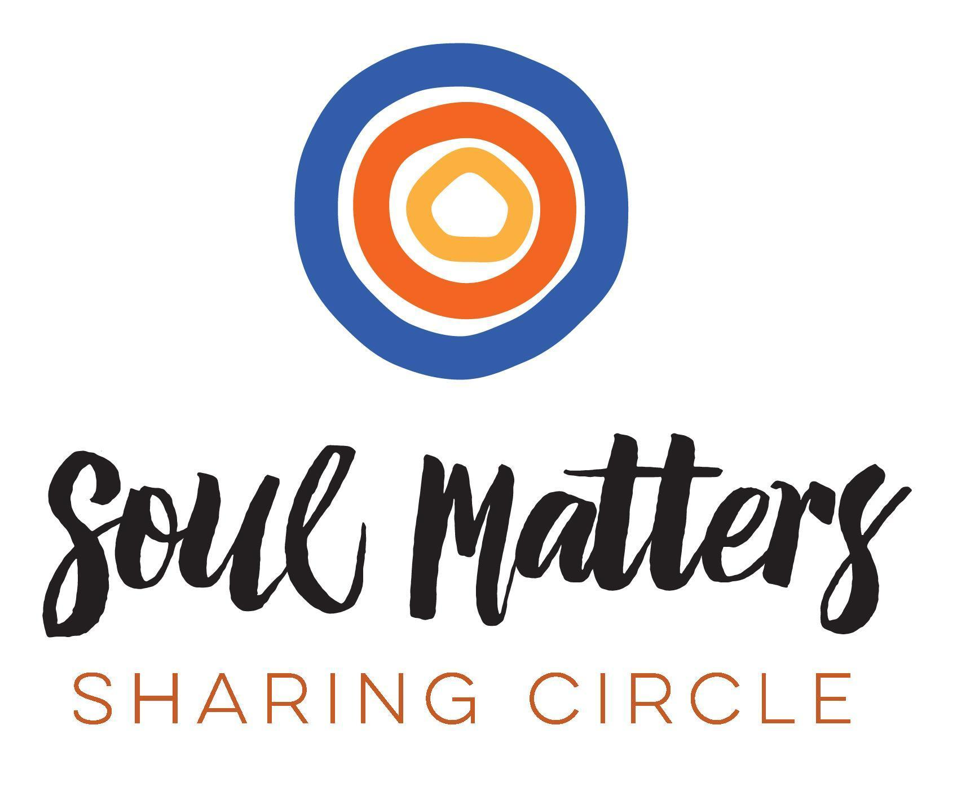

*© 2024-25 Soul Matters ALL RIGHTS RESERVED*

***Packets are for use only by member congregations of the Soul Matters Sharing Circle.***

*Learn how to join at* [*https://www.soulmatterssharingcircle.com*](https://www.soulmatterssharingcircle.com)