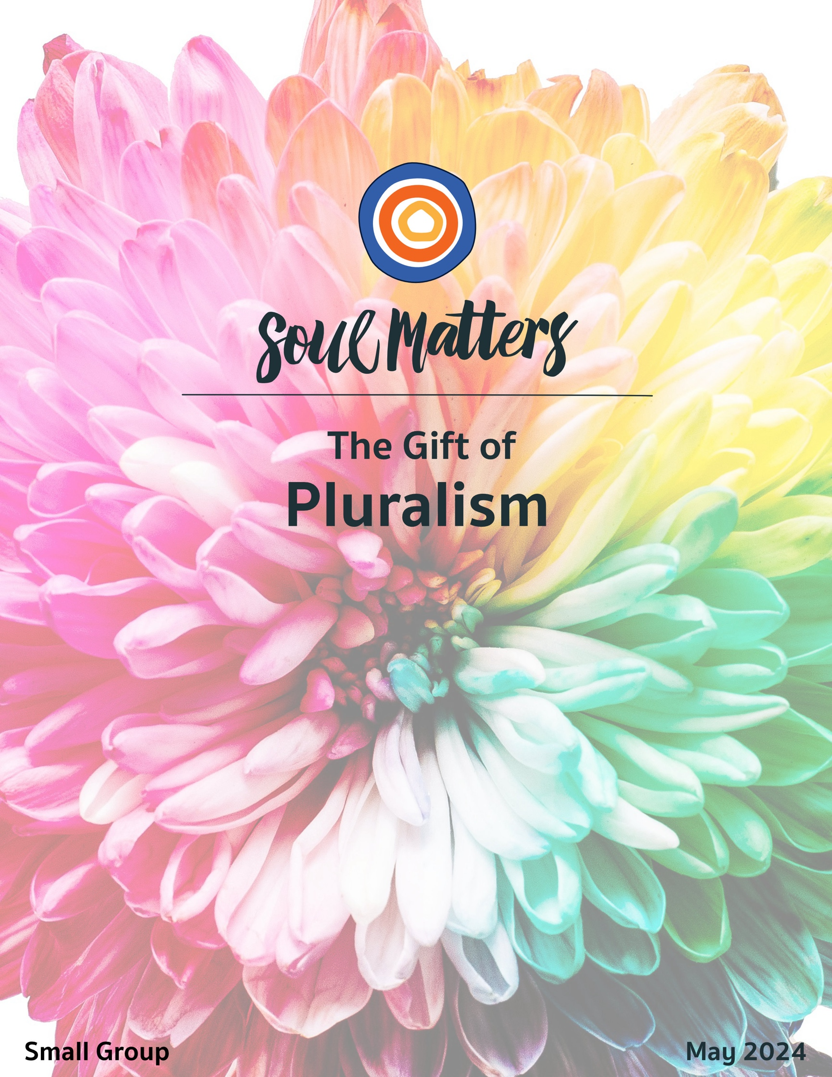

Welcome to the Gift of Pluralism

I wonder how the moonflower feels
about its sweet sister, the morning glory.
What it must be to know that world longingly awaits another
while you must seek solace hidden under a night sky.

When the world has told you to hide,
it is only the shadows that welcome you in.
And while blooming in the dark has its beauty,
it’s also a lonely way to live.

And who can blame this moon-drenched cousin for wanting to hide.
After all, we too know what happens out there in the light of day.
We are parsed and picked over,
told who and what we need to be,
so that we will finally be loved,
finally let in.

And so we shape shift
until our own original curvature is no longer remembered,
until our masks become indistinguishable from our face,
until the pieces of us allowed out in the sun
forget the parts buried deep in the cold earthen layers of time.

Maybe that is what the moonflower
is doing out there in the dark.
Maybe it’s not hiding after all
but instead trying to remember
who it once was.
Or maybe it knows who it is
and its blooming is a way of saying
“Come find me. I’m still here.”

Which, of course, means that maybe this month
is not just about making it safe for others to come out of the shadows
but also a reminder that we all have pieces and parts buried in the dark.

So friends, what do you say?
Let’s go find them.
Let’s put ourselves back together again.

Our Spiritual Exercises
It’s one thing to analyze a theme; it’s quite another to experience it. By pulling us out of the space of thinking and into the space of doing, these exercises invite us to figure out not just what we have to say about life, but also what life has to say to us!

Pick the exercise that speaks to you the most. Come to your group ready to share why you picked the exercise you did and what gift it gave you.

Option A

Your Personal Pluralism - Mapping Your Many Identities

Pluralism is most often applied to conversations about communities. But it’s just as relevant to individuals. We don’t have an identity; we have identities. As Walt Whitman famously said, “I am large, I contain multitudes!”

But we rarely - if ever - step back to reflect on how those multitudes influence us and interact with each other. And without that reflective distance, our many identities end up sneaking into the driver’s wheel. So this month spend some time getting to know your many selves, your pluralism within.

- Start by mapping/listing as many of your identity markers as you can. We’ve put together a chart with various identity categories to help: https://docs.google.com/document/d/17LZghnZV3QnNB_zLx7ug7yDdkO9t_8RFMDvN87fBb8A/edit?usp=sharing
- Reflect on your list of identities using this set of questions: https://docs.google.com/document/d/1BCaeslU2lnY-nQRJ29iYjk7rFqEV87ooqCNW7mxE19E/edit?usp=sharing
- Discuss your answers with a friend or family member. While doing this activity and reflection on your own is fine, you will get more out of it by pairing up with someone close to you. Your insights will go deeper by having to explain your answers to someone else and the discussion will help deepen the relationship between the two of you. Be sure to have your discussion partner complete the Identity Mapping Chart and questions before your discussion.
- Extra Mile: Bring some creativity to this exercise by taking your list of identities and reflections on them and turning them into a piece of writing. For instance, a narrative version like this one by adrienne maree brown or a poem like this one or this one.

Option B

Is Our Polarization More Pluralistic Than We Thought?

In addition to personal pluralism, there is - of course - political pluralism. With the presidential election gathering steam, possibly no topic is as pressing as how does America move away from a dangerous polarization and into a healthy pluralism?

But before we jump into that, it seems important to step back and ask, “Is our polarization more pluralistic than we thought?” In fact, that’s the claim of a recent study. It argues that our political landscape is not just divided into liberal and conservative camps. Apparently, there is a third segment of voters that may be the most important and determinative group of all. So for your exercise this month, dive into that study with the following interview and podcast. Come to your group ready to share how they challenged and even changed your mind.

Interview: What Motivates the Voters with a 'Need for Chaos'?

Podcast: Why the “Need for Chaos” Is Eating American Politics

Option C

Our Collections: Odes to Pluralism!

When we think of where pluralism shows up in our lives, one of the most universal, but also most overlooked, is our collections. Just think about how many of us collect baseball cards, comic books, coins, sea shells, fossils and Star Wars figures. And if you don’t consider yourself a collector, think again! Just look around your house at the overflowing spice rack in your kitchen and the endless books on your study’s shelves. Or what about the myriad of flowers you’ve gathered and collected outside your house or the glorious collection of shoes in your closet or all the eyeglasses or hair clips on your dresser!

This collecting has gone on for centuries and seems to serve a central human function, even a central sacred function. In short, these collections aren’t just interesting objects; they are objects that carry, contain and help us hold on to precious pieces and parts of ourselves and our memories.

So as a way of exploring this precious pluralism of our collections and ourselves, use this month to reflect on and creativity play with your collection(s).

- Get Inspired
Start by engaging the history and meaning of collections with these links:
- The History of Collecting
- Collecting brings meaning to our lives
- Lisa Congdon's 365 Collections
- More of Lisa Congdon’s collections
- Various artistically presented collections

- Identify
Identify both the many things you collect and the favorite thing you collect. Again, you likely have collections that you don’t think of as collections. (Remember that overflowing spice rack, the rows and rows of shoes in your closet and the completely unnecessary number of tools in your garage!)

- Reflect
This is certainly a fun exercise, but it’s also a doorway into deeper reflection. Here are some questions to help take you there:
- What was going on in your life when you started the collection? How has that event and your collection shaped each other? What is the relationship between the two?
- What purpose does the collection serve? i.e. Why do you do it? Is it an outlet for your curiosity
- about the world, a means of emotional comfort, a way to bond with other collectors, a path to experience the “joy of the hunt,” an expression of how devoted you are as a fan, or a means of holding on to memory? Or some of all the above?
- How do you display your collection and what meaning is attached to that?
- Do others know about it, or do you keep it hidden and private? If private, why is that? And is it private from everyone or just select groups? How and why did you draw that line?
- What does the collection say about you? And your values?
- How are these collections a “collection of you”?
- What story do your collected objects tell?
- Why is the collection “valuable”?

- Play
Now get creative and artistically arrange your collection, and then photograph your arrangement to share with your group. How you arrange it is up to you, but this video and these images offer some help. We suggest you arrange and photograph your collection(s) in multiple ways to open up some space for you to view your collection(s) in a new light.

Option D

Test Yourself

Political polarization is in the way of healthy political pluralism. And misperceptions about ourselves and our political “opponents” is arguably one of the main drivers of polarization.

Addressing such political misperceptions of others and ourselves is what these quizzes are all about. So, dig in, get informed… and have some fun!

The Perception Gap Quiz
Be sure to read this article about other findings from this group.

- Pew Research Quiz
At the end of the quiz and after it gives you information about your results, there is a button inviting you to, “Select another typology group to learn more about it.” Be sure to check this out.

- Politics of Disgust Quiz
Don’t pass this one up, even if it sounds odd. Be sure to check out this related TED Talk and book.

New York Times Quiz
Just imagine if we had a strong six-party system rather than a dysfunctional two-party one!

- Political Bias Quiz
Related article: https://www.vox.com/2015/9/10/9188517/political-bias
This is one we all need to spend time with!

Option E

The Many Views from Your Many Windows

We talk a lot about how our different perspectives help us understand this life of ours more fully. But might it also be true that those different views help us appreciate this life more fully as well? That is the idea behind the “View From My Window” movement that came into being during Covid. The effort simply asked people to take a picture from their window and share it with others online. Doing so not only got everyone vicariously outside when everyone was afraid of doing that in person, but it also renewed people’s spirits by reminding them that life offers us beauty in so many forms, not just struggle in so many forms.

So for your creative project this month, play with views from a window. There are many ways to approach this. You could collect pictures from the many windows and views that make up your life, taking photos from the windows at your home, your work, your favorite dinner, your car on a favorite drive. Or you could make it a group effort and ask your family and friends to send you pictures from their favorite window. If your congregation has a Creativity Matters group, you could also team up with members of that group and share views from your widows with each other.

Along the way and at the end, take some time to ask yourself what impact this has on you. What gift might life be trying to give you through it? How might it be trying to remind you that life offers us beauty in so many forms, not just struggle in so many forms. And why is that reminder so important to you right now?

(Learn more about the “View From Your Window” movement at
https://www.boredpanda.com/view-from-your-window/, and https://www.facebook.com/groups/286866152596429 )

Option F

Ask Them About Pluralism

One of the best ways to explore our monthly themes is to have conversations about them with people who are close to you. It not only deepens our conversations but also our relationships. Below is a list of “pluralism questions” to help you on your way.

Be sure to let your conversation partner know in advance that this won’t be a typical conversation. Telling them a bit about Soul Matters will help set the stage. Come to your group ready to share what surprised you about the conversation(s) and what gift or insight it gave you.

Pluralism Questions
- What were you taught in your family of origin about pluralism and welcoming difference? How does that still impact you today?
- Has an experience of being included permanently left a mark on you?
- If you weren’t afraid of being judged or rejected, what part of yourself would you let out into the world?
- If you could go back and change a moment of being excluded or excluding someone else, what would it be?
- What part of your pluralistic self do you have the hardest time acknowledging or embracing with compassion? Your judgmental self? Your lazy self? Your vulnerable self? Your bitter self? Your easily frightened self? Your quick-to-anger self? Your jealous self? Your petty self? Your selfish self?
- When it comes to age, our society is not as pluralistic as it thinks. Have you been ignored or cast out because of your age? Was it more emotionally challenging to accept than you expected?
- Our friends and family each carry/believe/tell a different story about who we are. Whose version of you most closely matches your authentic self? Whose version do you disagree with most strongly? Whose version challenges you to be your best self? Whose do you hope to someday become?

Option G

Which Pluralism Companion Piece Calls to You?

Sometimes we come across a quote, song, article or movie and it perfectly captures what’s going on for us right now. Or it allows us to view our current circumstances in a new light.

With this in mind, spend some time this month reading through the Companion Pieces section below to find the one that speaks most powerfully to you.

We encourage you to use the same discernment practice with the Companion Pieces as you do with the packet’s list of questions.
Come to your group ready to share your quote and the journey it took you on.

Your Question

This list of questions is an aid for deep reflection. They are not meant to be answered as much as to take you on a journey. Read through the questions 2-3 times until one question sticks out for you and captures your attention, or as some faith traditions say, until one of the questions “shimmers.”

Then reflect on that question using one or all of these questions:
- What is going on in my life right now that makes this question so pronounced for me?
- How might my inner voice be trying to speak to me through it?
- How might Life or my inner voice be trying to offer me a word of comfort or challenge through this question?

- What were you taught in your family of origin about pluralism and welcoming difference? How does that still impact you today?
- Has an experience of being included permanently left a mark on you?
- Whose refusal to conform made it possible for you to add your uniqueness to the diversity of the world?
- If you could go back and change a moment of being excluded or excluding someone else, what would it be?
- Have you ever been treated like a category rather than a person?
- If you weren’t afraid of being judged or rejected, what part of your diverse self would you let out into the world?
- What part of your pluralistic self do you have the hardest time acknowledging or embracing with compassion? Your judgmental self? Your lazy self? Your vulnerable self? Your bitter self? Your easily frightened self? Your quick-to-anger self? Your jealous self? Your petty self? Your selfish self?
- What aspect of your life partner, child or close friend do you need to do a better job of embracing and welcoming in?
- When it comes to age, our society is not as pluralistic as it thinks. Have you been ignored or cast out because of your age? Was it more emotionally challenging to accept than you expected?
- Is it possible that the aspect that so annoys you about that other person echoes a similar part of yourself you deny?
- It’s said that we exile the parts of ourselves that were once humiliated in our past. Which tender part of your younger self is whispering, “Please let me back in.”
- It’s said “Whoever is underrepresented in your life, will be overrepresented in your imagination.“ So who is underrepresented in your life? Are they overrepresented in your imagination?
- Most on-going disagreements are sources of pain, division and discomfort. But ironically some disagreements feel “fruitful“ ;They somehow enrich us and our relationships. How has a precious “fruitful disagreement” changed you? Is there wisdom from this fruitful disagreement that could be applied to other areas of your life?
- Our friends and family each carry/believe/tell a different story about who we are. Whose version of you most closely matches your authentic self? Whose version do you disagree with most strongly? Whose version challenges you to be your best self? Whose do you hope to someday become?
- What’s your question? Your question may not be listed above. As always, if the above questions don't include what life is asking from you, spend the month listening to your days to find it.

Companion Pieces

Recommended Resources for Personal Exploration & Reflection

The following resources are not required reading. We will not analyze these pieces in our group.
Instead they are here to companion you on your journey this month, get you thinking
and open you up to new ways of imagining the gift of pluralism.

Wise Words

There are many ways to kneel and kiss the ground.
Rumi

Lives are lived in parallel and perpendicular, fathomed nonlinearly, figured not in the straight graphs of “biography” but in many-sided, many-splendored diagrams… There are infinitely many kinds of beautiful lives.
Maria Popova

Inclusivity is not ‘how do we make you a part of what we are?’ but ‘how do we become more of what you are?’
angel Kyodo williams Sensei

Diversity is being invited to the party; inclusion is being asked to dance.
Verna Myers

Diversity is not just about the differences you like.
Eboo Patel

Pluralism isn’t easy. It’s a constant willingness to self-challenge and to look at where we might be wrong, or limited; even with regard to pluralism itself. It requires a capacity to detach ourselves from our agendas, our beliefs, our commitments, and to recognize that there may be other ways. And it also requires us to recognize that we can never wholly achieve that.
Mick Cooper

Differences challenge assumptions.
Anne Wilson Schaef
He drew a circle that shut me out-
Heretic, rebel, a thing to flout.
But love and I had the wit to win:
We drew a circle and took him In!
Edwin Markham

You have your way. I have my way. As for the right way, the correct way, and the only way, it does not exist.
Friedrich Nietzsche

When we lose the right to be different, we lose the privilege to be free.
Charles Evan Hughes

If I had access to people who looked like me growing up, my life would have been so much easier. The suicide rates for trans and non-binary youth, especially trans and non-binary youth of color, are astronomical. And the reason they're so high is because when you tell us we don’t exist, at some point we begin to believe you. And media representation is actually a visual argument to the world, [saying], “We’re here. We’re queer. We’re trans. We’re people of color. We’re gender non-conforming. Our lives matter. We're going and navigating through things that are simultaneously extremely similar to you and extremely different for you, and you cannot erase us!”
Alok Vaid-Menon

The first thing I am is a person… But people either relate to you as an Indian or as a woman. They relate to you as a category.
Winona LaDuke

Ask yourself, “What kinds of people do I talk about but never talk with?” Whoever is underrepresented in your life, will be overrepresented in your imagination!... This is the truth of our divided landscape.
Mónica Guzman

Our [many] identities… should be praised, celebrated and paraded in the streets. They are Mardi gras and gumbo pots… refusing to be boxed in.
Lana LosAngeles
People are just as wonderful as sunsets if I can let them be. In fact, perhaps the reason we can truly appreciate a sunset is that we cannot control it. When I look at a sunset as I did the other evening, I don’t find myself saying, ‘Soften the orange a little on the right hand corner, and put a bit more purple along the base, and use a little more pink in the cloud color.’ I don’t do that. I don’t try to control a sunset. I watch it with awe as it unfolds. I like myself best when I can appreciate my staff member, my son, my daughter, my grandchildren, in this same way.
Carl Rogers

The most peaceful people that I know, and the most wise people that I know, are the ones who have created enough internal space to be able to allow all the parts of themselves to coexist despite the contradictions. So they have room for their creativity. They also have room for their fear. They have room for their dignity. They also have room for their shame. They have room for the parts of themselves that are glorious and divine and wonderful. And they have room for the parts of themselves that are petty and jealous and ridiculous. Right? Like, they create this big, huge auditorium of a landscape inside themselves. They don't kick any parts out, because guess what? You can't.
Elizabeth Gilbert

Why be a star when you can make a constellation?
Mariam Kaba

To be free, you must embrace
the breadth of your own existence
without apology…
But to actually be free, you must
know and you must fight for the entire
Universes inside of everyone else.
Julián Jamaica Soto

Once we reckon with the paradox of how the perceived other is both distinct, and a direct reflection of us, then we see ourselves in that mirror. We see everyone and everything as reflecting an aspect of ourself that we get to reclaim. Those we might have judged become guideposts for our own liberation. Our triggers become welcomed signs that we have rejected
something inside us. The idea that you are either with us or against us is a limiting lens that perpetuates humanity's suffering. The recognition that you are us, that everyone is us, allows our self-love to humanize others into belonging.
Gareth Gwyn

The religious community is essential, for alone our vision is too narrow to see all that must be seen, and our strength too limited to do all that must be done. Together, our vision widens.
Rev. Dr. Mark Morrison-Reed

Because she wanted everyone to feel included
in her prayer, she said right at the beginning
several names for the Holy:
Spirit, she said, Holy One, Mystery, God…
Then, although she hadn’t imagined it this way,
others began to offer names:
Peace, said one.
One My Mother Knew, said another.
Ancestor, said a third.
Wind. Rain. Breath, said one near the back.
Refuge. That Which Holds All…
And then, there wasn’t any need to say the things
she’d thought would be important to say,
and everyone sat hushed, until someone said
Amen.
Nancy Shaffer

When you’re standing, beholding the presence of God, at that point you’re not going to be turning around and asking to yourself, ‘How did you get here? Which path did you follow to get to this point?’ No, you’re just going to be absorbed in the presence of God. And so is the person to your left. And so is the person to your right.
Dr. Omid Safi

Music
Our theme-based playlists - in Spotify and YouTube - are organized as a journey of sorts, so consider listening from beginning to end and using them as musical meditations.

Click here for the Spotify playlist on Pluralism.
Click here for the YouTube playlist on Pluralism.

Videos & Podcasts

On the “Cathedral of the World” as a Metaphor for UU Pluralism
https://www.tiktok.com/@revjo.uu/video/7157480430634175790

That Which Holds All, by Nancy Shaffer
https://www.youtube.com/watch?app=desktop&v=3prjmO1GpBk
Read the text here

Echo
https://kottke.org/24/01/a-blind-teacher-using-echolocation-to-navigate-the-world
A celebration and reminder of the many ways we perceive and navigate our world!

My Hometown, Clementine von Radics
https://www.youtube.com/watch?v=blwmvSwvMDs
Does our pluralism extend to everyone’s hometowns?

On Existing Outside the Heteronormative Gender Binary, Alok Vaid-Menon
https://www.youtube.com/watch?v=j7Gh2n9kPuA

How We Live With Contradictions
https://hiddenbrain.org/podcast/how-we-live-with-contradictions/
On our inability to tolerate the contradictory parts of ourselves and how we tell ourselves rationalizing stories to make those contradictions (seemingly) go away.

How To Talk To The Worst Parts Of Yourself (awesome and funny!)
https://www.youtube.com/watch?v=gUV5DJb6KGs

How Identity Politics Took Over the Republican Party
https://www.nytimes.com/2021/08/13/opinion/ezra-klein-podcast-lilliana-mason.html

Red Brain, Blue Brain
https://hiddenbrain.org/podcast/red-brain-blue-brain/

The “Need for Chaos” Is Eating American Politics
https://www.theringer.com/2024/3/1/24086888/why-the-need-for-chaos-is-eating-american-politics
This provocative podcast argues that the problems of our current political environment are more complicated and ironically pluralistic than we thought. It is not just about lovers of Trump and lovers of liberalism, but also lovers of chaos, who feel hopelessly stuck in and excluded by our current system and so want to see it destroyed.

Articles

I May Never Go to Disneyland
https://courtney.substack.com/p/i-may-never-go-to-disneyland
On honoring our many selves, including the ones we had to leave behind.

Books

Uncivil Agreement: How Politics Became Our Identity

The Wall Between: What Jews and Palestinians Don't Want to Know about Each Other

Apeirogon (fiction)

What Can a Body Do?: How We Meet the Built World

The Other Significant Others: Living and Loving Outside the Confines of Conventional Friendship and Compulsory Coupledom
On how “primary relationships” are becoming more and more pluralistic.

Movies

The Farewell
Disclosure
Hamtramck, USA
Black Panther
Billy Elliot
Pushing Hands

© 2023-24 Soul Matters ALL RIGHTS RESERVED
Packets are for use only by member congregations of the Soul Matters Sharing Circle.
Learn how to join at https://www.soulmatterssharingcircle.com

